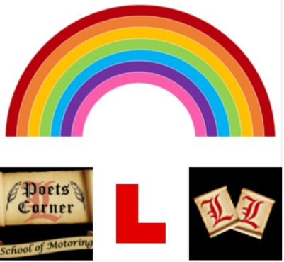
POETS CORNER SCHOOL OF MOTORING
COVID 19 CODE OF PRACTICE:
DISCLAIMER:
As you can see we are putting all this in place to make sure you and your instructor are as safe as possible during your lessons but there are no guarantees that this will be enough so if you do contract the virus we can't be held responsible and it's quite possible you would have probably caught it from another source anyway.
If you find ‘Poets Corner School of Motoring Covid Code of Practice’ satisfactory, can you please sign to say that you accept that you are entering the vehicle at your own risk.
Pupil’s signature: ............................................
Pupil’s name: .............................................

